1. INTRODUCTION
This document describes the design, implementation and testing of a basic interactive graphical user interface (GUI) application built with Java Swing for the PROG209 Event Driven Programming module. Event driven programming is a paradigm in which the flow of the program is determined by events such as button clicks, which are detected by the user interface and passed to handler code (Oracle, n.d.a). Swing is the toolkit in the Java platform that provides the windows, panels, labels and buttons needed to build this type of application (Oracle, n.d.b).
The application opens a single window that shows a heading, a custom-drawn logo and a welcome message. Two buttons let the user change the text of the label and change the background colour of the panel, which demonstrates how user actions are handled through event listeners. The program also demonstrates inheritance and the use of constructors, as required by the assignment brief.

2. OBJECTIVES AND REQUIREMENTS
The assignment brief requires a basic GUI application that includes a JFrame, a JLabel and a JPanel and that implements inheritance and a constructor. The requirements are summarised below together with the part of the solution that addresses each of them.
Requirement | How it is addressed
Class named SwingAssignment | The public class SwingAssignment contains all application logic and the main method.
JFrame variable named frame | Declared as a field and instantiated in the constructor with the title "Java Swing Assignment".
JPanel variable named panel | Declared as a field and instantiated as a WelcomePanel, which is a subclass of JPanel.
JLabel variable named label | Declared as a field and instantiated with the welcome message, then added to the panel.
Close button ends the program | frame.setDefaultCloseOperation(JFrame.EXIT_ON_CLOSE).
Own application icon | An original monogram logo is drawn in code and set as the window icon.
Inheritance and constructor | WelcomePanel extends JPanel and LogoPanel extends JComponent; each defines its own constructor.
Addition: change label text and panel background | Two JButton components with ActionListener handlers.
Wireframe in Figma | See Section 4. The wireframe is shown as Figure 1.
GitHub and documentation | See Section 9.

3. TOOLS AND ENVIRONMENT
Tool | Purpose
Java Development Kit (JDK) | Compiling and running the application using the javax.swing and java.awt packages.
IntelliJ IDEA / VS Code | Writing, running and debugging the Java source code (JetBrains, n.d.).
Figma | Creating the wireframe of the interface before coding (Figma, n.d.).
Git and GitHub | Version control and submission of the project (GitHub, n.d.a).
Microsoft Word | Preparing this documentation.

4. WIREFRAME DESIGN
Before writing code, a low-fidelity wireframe was prepared to plan the layout. The interface is a single window with the content centred vertically. A heading sits at the top, followed by the logo and the welcome label, with the two action buttons placed together at the bottom. The wireframe is shown in Figure 1.
FIGMA WIREFRAME
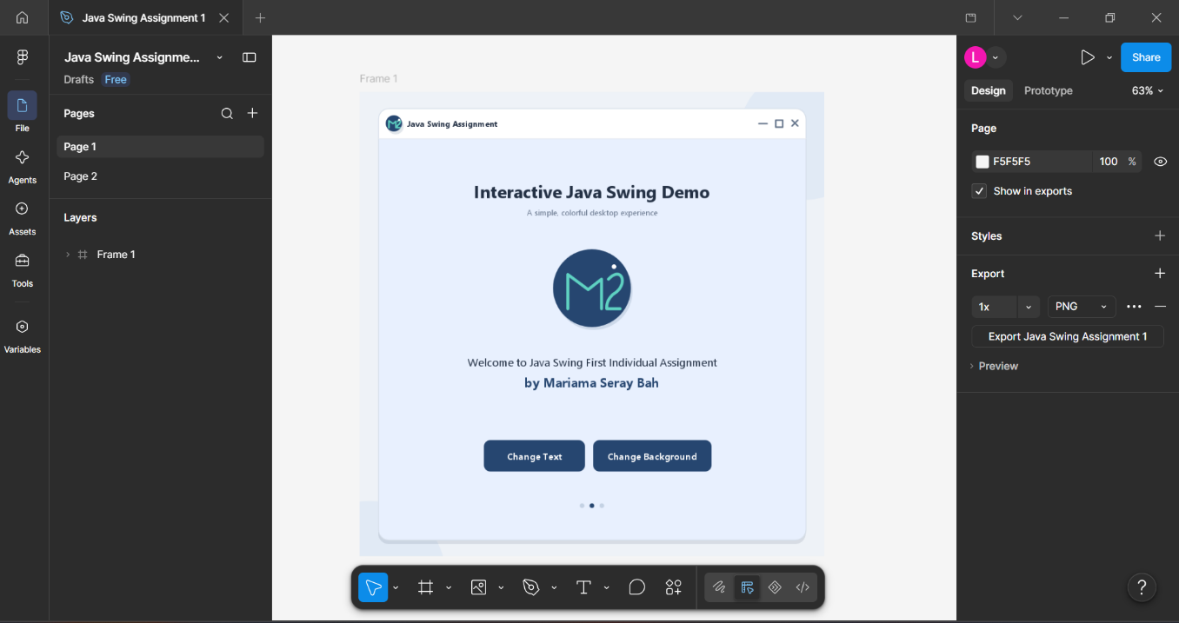

The layout decisions were guided by common interface design principles: a clear visual hierarchy, consistent spacing and controls grouped by function. The window uses a BorderLayout, in which the message area occupies the centre and the button area occupies the south region.

5. SYSTEM DESIGN

5.1 Class structure
The application is made up of one outer class and two nested classes, listed in Table 1.
Class | Extends | Responsibility
SwingAssignment | Object | Main class. Builds the frame, panel, label and buttons, wires up event handling and starts the program.
WelcomePanel | JPanel | Main content panel with a BorderLayout, padding and a changeBackground method.
LogoPanel | JComponent | Draws the monogram logo using Java 2D and supplies the window icon image.

5.2 Inheritance
Inheritance allows a class to reuse the fields and methods of an existing class and to add or change behaviour (Oracle, n.d.c). WelcomePanel extends JPanel, so it keeps everything a normal panel can do and adds a changeBackground method that sets the new colour and repaints the panel. LogoPanel extends JComponent and overrides the paintComponent method so that it draws the logo instead of the default empty appearance.

5.3 Constructors
A constructor is a special method with the same name as its class that runs when an object is created and prepares it for use (Oracle, n.d.d). The following constructors are used:
- SwingAssignment() creates the JFrame, the panel, the labels and the buttons and registers the event listeners.
- WelcomePanel() calls super(new BorderLayout(20, 20)) to initialise the parent JPanel with a layout, then sets the starting background colour and the padding border.
- LogoPanel() sets the preferred size to 112 by 112 pixels, centres the component and sets a tooltip.

6. IMPLEMENTATION

6.1 JFrame
The JFrame is the top-level window of the application (Oracle, n.d.e). The variable frame is created with the title "Java Swing Assignment", sized at 800 by 500 pixels and centred on the screen with setLocationRelativeTo(null). The call setDefaultCloseOperation(JFrame.EXIT_ON_CLOSE) makes sure that the program ends when the user clicks the close button.

6.2 JPanel
A JPanel is a lightweight container used to group and arrange components (Oracle, n.d.f). The variable panel is an instance of WelcomePanel and is added to the frame. Two further panels are used inside it: messagePanel, which stacks the heading, logo and label vertically with a BoxLayout, and buttonPanel, which centres the two buttons with a FlowLayout. Both are made transparent with setOpaque(false) so that the background colour of the main panel shows through.

6.3 JLabel
A JLabel displays text or an image and does not respond to user input directly (Oracle, n.d.g). The variable label holds the welcome message and is added to the panel. A second label, heading, shows the title of the window. Both use the Tahoma font and a dark blue-grey text colour for readability.

6.4 Application icon and logo
The application uses its own original icon rather than a file from another source. The LogoPanel class draws a circular badge with a stylised monogram using Java 2D shapes (Ellipse2D and Path2D) with anti-aliasing switched on. The same drawing is rendered into a BufferedImage by createLogoImage and passed to frame.setIconImage, so the logo appears both inside the window and in the title bar and taskbar. The Swing icon mechanism is described by Oracle (n.d.h).

6.5 Event handling
Swing uses the event listener model: a component generates an event when the user interacts with it, and any registered listener is notified (Oracle, n.d.i). Each button has an ActionListener, written as an anonymous inner class, that runs when the button is clicked.
- Change Text: increases messageIndex by one, wraps around using the modulus operator and calls label.setText with the next message from the LABEL_MESSAGES array.
- Change Background: increases colourIndex in the same way and calls panel.changeBackground with the next colour from the BACKGROUND_COLOURS array.

6.6 Event Dispatch Thread
Swing components are not thread safe and should be created and updated on the Event Dispatch Thread (Oracle, n.d.j). For this reason the main method uses SwingUtilities.invokeLater to build and show the window.

7. TESTING
The following test plan was used to check that the application meets the requirements. Each test should be carried out after compiling and running the program.
No. | Test action | Expected result | Requirement
1 | Run the program | A window titled "Java Swing Assignment" opens in the centre of the screen. | JFrame
2 | Observe the window contents | The heading, logo, welcome label and two buttons are displayed on the panel. | JPanel, JLabel
3 | Check the title bar and taskbar | The custom logo is shown as the window icon. | Application icon
4 | Click Change Text once | The label shows the second message. | Addition
5 | Click Change Text until the messages run out | The label returns to the first message. | Addition
6 | Click Change Background | The panel colour changes to the next colour in the list. | Addition
7 | Click Change Background seven times | The colours cycle back to the starting colour. | Addition
8 | Hover over the logo | The tooltip "Custom Java Swing assignment logo" appears. | Constructor
9 | Click the close button | The window closes and the program ends. | Close operation

8. APPLICATION SCREENSHOT

SCREENSHOT 1
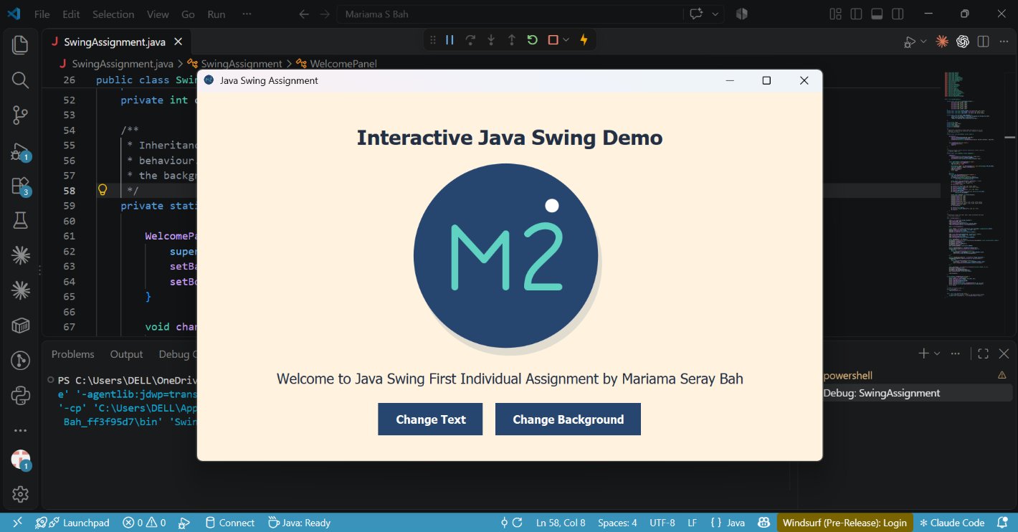

SCREENSHOT 2
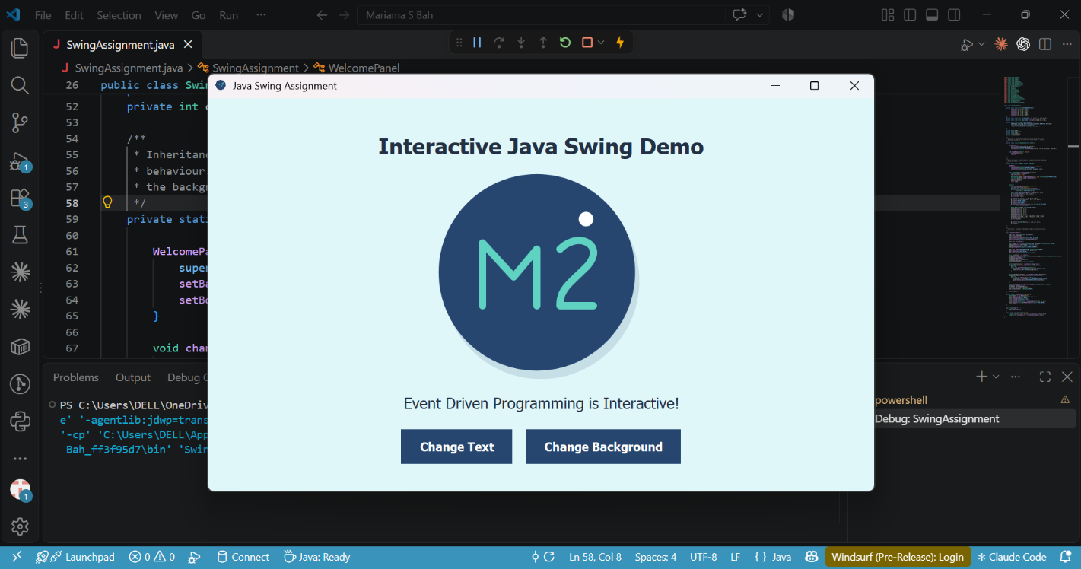

9. CONCLUSION
The project meets the aim of the assignment by producing a working Swing application that uses a JFrame, a JPanel and JLabel components, inheritance through WelcomePanel and LogoPanel, constructors in every class, and a custom application icon. The added buttons show the core idea of event driven programming: the program waits for the user and reacts when a click occurs. Possible improvements include a further menu bar, saving the chosen colour between sessions and replacing the anonymous inner classes with lambda expressions.

10. REFERENCES
- Figma (n.d.) Figma: the collaborative interface design tool. Available at: https://www.figma.com/ (Accessed: 21 October 2026).
- GitHub (n.d.a) GitHub Docs. Available at: https://docs.github.com/ (Accessed: 21 October 2026).
- GitHub (n.d.c) About READMEs. Available at: https://docs.github.com/en/repositories/managing-your-repositorys-settings-and-features/customizing-your-repository/about-readmes (Accessed: 21 October 2026).
- JetBrains (n.d.) IntelliJ IDEA: the leading Java and Kotlin IDE. Available at: https://www.jetbrains.com/idea/ (Accessed: 21 October 2026).
- Oracle (n.d.c) Inheritance. The Java Tutorials. Available at: https://docs.oracle.com/javase/tutorial/java/IandI/subclasses.html (Accessed: 21 October 2026).
- Oracle (n.d.e) How to make frames (main windows). The Java Tutorials. Available at: https://docs.oracle.com/javase/tutorial/uiswing/components/frame.html (Accessed: 21 October 2026).

APPENDIX A: SOURCE CODE (SWINGASSIGNMENT.JAVA)
import javax.swing.JButton;
import javax.swing.JFrame;
import javax.swing.JLabel;
import javax.swing.JPanel;
import javax.swing.JComponent;
import javax.swing.SwingConstants;
import javax.swing.SwingUtilities;
import javax.swing.BorderFactory;
import java.awt.BasicStroke;
import java.awt.Color;
import java.awt.Font;
import java.awt.FlowLayout;
import java.awt.BorderLayout;
import java.awt.Dimension;
import java.awt.Cursor;
import java.awt.Graphics;
import java.awt.Graphics2D;
import java.awt.RenderingHints;
import java.awt.event.ActionEvent;
import java.awt.event.ActionListener;
import java.awt.geom.Ellipse2D;
import java.awt.geom.Path2D;
import java.awt.image.BufferedImage;

public class SwingAssignment {

private static final Color[] BACKGROUND_COLOURS = {
new Color(232, 240, 254),
new Color(232, 245, 233),
new Color(255, 243, 224),
new Color(243, 229, 245),
new Color(224, 247, 250),
new Color(255, 235, 238),
new Color(236, 239, 241)
};
private static final Color BUTTON_COLOUR = new Color(38, 70, 112);
private static final Color TEXT_COLOUR = new Color(35, 48, 68);
private static final Color LOGO_ACCENT = new Color(95, 210, 194);

private static final String[] LABEL_MESSAGES = {
"Welcome to Java Swing First Individual Assignment by Mariama Seray Bah",
"Event Driven Programming is Interactive!",
"Thanks for exploring this interactive interface.",

};

private JFrame frame;
private WelcomePanel panel;
private JLabel label;
private int messageIndex;
private int colourIndex;

/**
* Inheritance: WelcomePanel extends JPanel and inherits all of its
* behaviour. It adds its own constructor and a method for changing
* the background colour.
*/
private static class WelcomePanel extends JPanel {

WelcomePanel() {
super(new BorderLayout(20, 20));
setBackground(BACKGROUND_COLOURS[0]);
setBorder(BorderFactory.createEmptyBorder(40, 48, 32, 48));
}

void changeBackground(Color colour) {
setBackground(colour);
repaint();
}
}

/**
* Draws an original, project-specific monogram mark without requiring
* a separate image file.
*/
private static class LogoPanel extends JComponent {

LogoPanel() {
setPreferredSize(new Dimension(112, 112));
setAlignmentX(JComponent.CENTER_ALIGNMENT);
setToolTipText("Custom Java Swing assignment logo");
}

static BufferedImage createLogoImage(int size) {
LogoPanel logo = new LogoPanel();
logo.setSize(size, size);

BufferedImage image = new BufferedImage(size, size, BufferedImage.TYPE_INT_ARGB);
Graphics2D graphics = image.createGraphics();
logo.paint(graphics);
graphics.dispose();
return image;
}

@Override
protected void paintComponent(Graphics graphics) {
super.paintComponent(graphics);
Graphics2D g2 = (Graphics2D) graphics.create();
g2.setRenderingHint(RenderingHints.KEY_ANTIALIASING,
RenderingHints.VALUE_ANTIALIAS_ON);

double scale = Math.min(getWidth(), getHeight()) / 112.0;
g2.translate((getWidth() - 112 * scale) / 2,
(getHeight() - 112 * scale) / 2);
g2.scale(scale, scale);

g2.setColor(new Color(38, 70, 112, 35));
g2.fill(new Ellipse2D.Double(9, 11, 94, 94));
g2.setColor(BUTTON_COLOUR);
g2.fill(new Ellipse2D.Double(7, 7, 94, 94));
g2.setColor(LOGO_ACCENT);
g2.setStroke(new BasicStroke(3.5f, BasicStroke.CAP_ROUND,
BasicStroke.JOIN_ROUND));

Path2D.Double monogram = new Path2D.Double();
monogram.moveTo(28, 70);
monogram.lineTo(28, 40);
monogram.lineTo(43, 56);
monogram.lineTo(54, 43);
monogram.lineTo(54, 70);
monogram.moveTo(65, 43);
monogram.curveTo(74, 34, 87, 41, 78, 51);
monogram.curveTo(69, 60, 65, 62, 65, 70);
monogram.lineTo(81, 70);
g2.draw(monogram);

g2.setColor(Color.WHITE);
g2.fill(new Ellipse2D.Double(74, 25, 7, 7));
g2.dispose();
}
}

/**
* Constructor: builds the frame, panel, labels and buttons and wires
* up the event handling.
*/
public SwingAssignment() {

frame = new JFrame("Java Swing Assignment");
frame.setSize(800, 500);
frame.setLocationRelativeTo(null);
frame.setDefaultCloseOperation(JFrame.EXIT_ON_CLOSE);
frame.setIconImage(LogoPanel.createLogoImage(128));

panel = new WelcomePanel();

JLabel heading = new JLabel("Interactive Java Swing Demo", SwingConstants.CENTER);
heading.setFont(new Font("Tahoma", Font.BOLD, 26));
heading.setForeground(TEXT_COLOUR);
heading.setAlignmentX(JComponent.CENTER_ALIGNMENT);

label = new JLabel(LABEL_MESSAGES[0], SwingConstants.CENTER);
label.setFont(new Font("Tahoma", Font.PLAIN, 18));
label.setForeground(TEXT_COLOUR);
label.setAlignmentX(JComponent.CENTER_ALIGNMENT);

JPanel messagePanel = new JPanel();
messagePanel.setLayout(new javax.swing.BoxLayout(messagePanel, javax.swing.BoxLayout.Y_AXIS));
messagePanel.setOpaque(false);
messagePanel.add(heading);
messagePanel.add(new LogoPanel());
messagePanel.add(label);
panel.add(messagePanel, BorderLayout.CENTER);

JButton changeTextButton = createButton("Change Text");
changeTextButton.addActionListener(new ActionListener() {
@Override
public void actionPerformed(ActionEvent e) {
messageIndex = (messageIndex + 1) % LABEL_MESSAGES.length;
label.setText(LABEL_MESSAGES[messageIndex]);
}
});

JButton changeBackgroundButton = createButton("Change Background");
changeBackgroundButton.addActionListener(new ActionListener() {
@Override
public void actionPerformed(ActionEvent e) {
colourIndex = (colourIndex + 1) % BACKGROUND_COLOURS.length;
panel.changeBackground(BACKGROUND_COLOURS[colourIndex]);
}
});

JPanel buttonPanel = new JPanel(new FlowLayout(FlowLayout.CENTER, 16, 0));
buttonPanel.setOpaque(false);
buttonPanel.add(changeTextButton);
buttonPanel.add(changeBackgroundButton);
panel.add(buttonPanel, BorderLayout.SOUTH);

frame.add(panel);
}

private JButton createButton(String text) {
JButton button = new JButton(text);
button.setFont(new Font("Tahoma", Font.BOLD, 14));
button.setForeground(Color.WHITE);
button.setBackground(BUTTON_COLOUR);
button.setFocusPainted(false);
button.setBorder(BorderFactory.createEmptyBorder(12, 22, 12, 22));
button.setCursor(Cursor.getPredefinedCursor(Cursor.HAND_CURSOR));
return button;
}

/** Makes the window visible. */
public void show() {
frame.setVisible(true);
}

public static void main(String[] args) {
// Swing components should be created on the Event Dispatch Thread
SwingUtilities.invokeLater(() -> new SwingAssignment().show());
}
}

